FINAL PROJECT
Job Tracking & Customer Visit Analytics Pipeline
NAME-Naman verma
ID-CT_CSI_DE_789
SQL QUERY RESULT

1->
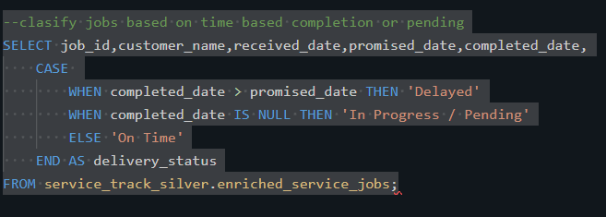
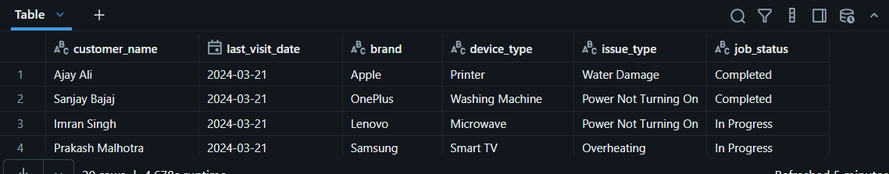
2->
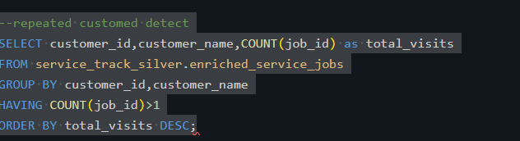
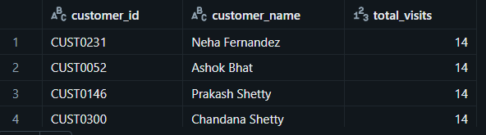
3->
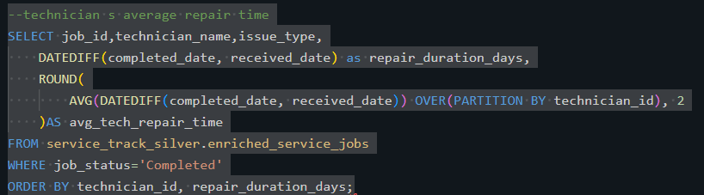
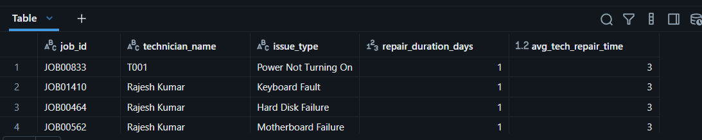
4->
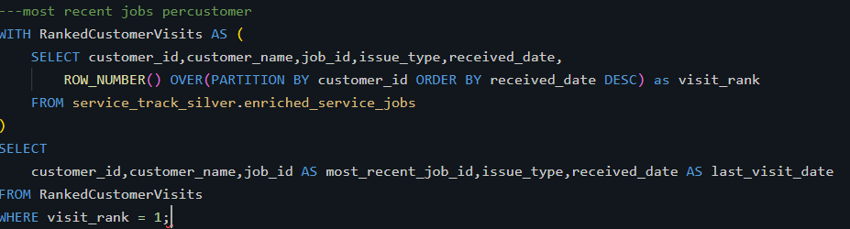
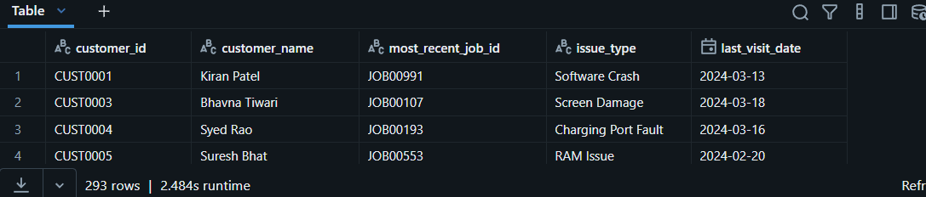
5->
